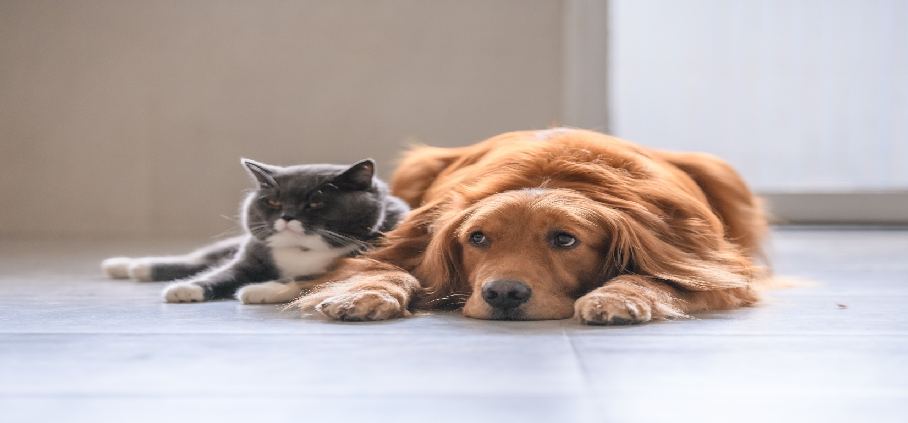
Keep the Shelter Pets Warm and Happy This Winter!
For our next service project, we will be collecting donations at our January meeting for the shelter pets at Montgomery County Animal Shelter. Help keep the homeless pets of our county comfortable while they look for their fur-ever family.

Wanted items include:
- New and Used Towels and Blankets
- Puppy “pee” Pads
- Wet/Dry Purina One or Purina Pro Plan Puppy or Adult Food
- Dog Treats: Soft Treats Preferred
- Electric Heating Pads
- Kong Toys/Nyla Bones
- Baby Wipes – Unscented
- Pill Pockets
- Dog Toys

